**Authors: Owen Arnold1,2, Anton Piccardo-Selg1, Vickie Lynch3, Peter Peterson3, Nick Draper1,2**

**Affiliations:** Tessella, ISIS-STFC, SNS-ORNL

**Preferred type of communication:** Poster

**Topics:** “Neutron Instrumentation, Optics, Sample Environment, Detectors and Software”

**Title (plain text only):** Visualisation and Analysis in Mantid for Single Crystal Neutron Diffraction

**Title (formatted text):** Visualisation and Analysis in Mantid for Single Crystal Neutron Diffraction

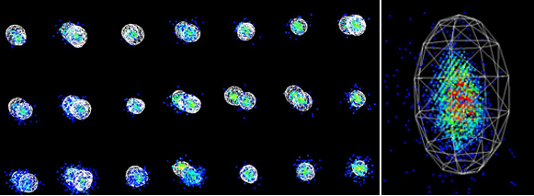

Large neutron scattering datasets are commonly collected at TOF sources, particularly for single crystal diffraction experiments. A full understanding of the materials of interest often requires the complete mapping of data in an n-dimensional manifold. Increasingly, and particularly in single crystal diffraction, the correct treatment of data as part of data reduction and analysis, for a range of techniques, involves the efficient and flexible processing of large n-dimensional datasets.

The Mantid1,2 framework, our extensible framework for neutron and muon data reduction and analysis, has been successfully deployed for use on a large range of instruments. An on-going area of development within that framework has been the development of tools to analyse and visualise n-dimensional data. This work has involved collaboration between ISIS at RAL, SNS at Oakridge and the ESS in Lund.

Additional complexities introduced in single crystal diffraction techniques are to accurately find, index, and integrate peaks with minimal user-intervention. The integration alone presents a major challenge, and this has been an area of focus for us recently. Our initial offering was based on a spherical integration approach, with in momentum-transfer space, we found this worked well in some, but not all cases. We have since developed new algorithms based on a peak-by-peak principle component analysis for which the integrated region falls into an ellipsoid. For weak and diffuse peaks, we have developed a solution using connected component analysis to identify and integrate arbitrary peak shapes over the background.

Visualisation has become a fundamental part of the data-treatment in single crystal diffraction, not just an end output. Users need to retain the ability to step-in to the processing, for example by editing and separating of peaks lists and verifying complex 3D integration regions against the recorded data via visual inspection, and printable reports for archiving and later reference.

**References**

[1] [www.mantidroject.org](http://www.mantidroject.org)

[2] O. Arnold, et al., Mantid—Data analysis and visualization package for neutron scattering and μSR experiments, Nuclear Instruments and Methods in Physics Research Section A, Volume 764, 11 November 2014, Pages 156-166, <http://dx.doi.org/10.1016/j.nima.2014.07.029>